**ASK YOUR SENIOR**

**“YOUR PLACEMENT PARTNER"**

Dr Rakesh Kumar M

Computer Science and Engineering

Rajalakshmi Engineering College,

Chennai, India

[rakeshkumar.m@rajalakshmi.edu.in](mailto:rakeshkumar.m@rajalakshmi.edu.in)

Sakthilakshmi M Computer Science and Engineering

Rajalakshmi Engineering College, Chennai, India

[210701223@rajalakshmi.edu.in](mailto:210701210@rajalakshmi.edu.in)

Ranjith Kumaran Computer Science and Engineering

Rajalakshmi Engineering College,

Chennai, India

210701209@rajalakshmi.edu.in Raveena Sri R Computer Science and Engineering

Rajalakshmi Engineering College, Chennai, India

[210701210@rajalakshmi.edu.in](mailto:210701210@rajalakshmi.edu.in)

Rachel Sherin J Computer Science and Engineering

Rajalakshmi Engineering College,

Chennai, India

210701200@rajalakshmi.edu.inSam Lawrence Computer Science and Engineering

Rajalakshmi Engineering College,

Chennai, India

[210701225@rajalakshmi.edu.in](mailto:210701223@rajalakshmi.edu.in)

Priscilla Rachel Computer Science and Engineering

Rajalakshmi Engineering College,

Chennai, India

210701196@rajalakshmi.edu.in

Abstract**—Students face difficulty while preparing for their interviews. They have various doubts like how to prepare and what to prepare for technical rounds.**

**Ask Your Senior is a bridge between the juniors and seniors which will help them to obtain information relevant to placements and the preparation strategies for interviews. Students can clear their doubts by asking their queries to the chatbot. We are collecting the information about the placements from the seniors who have attended the interview and have experience in how to prepare for the interview. This is our creative idea which will guide the students in preparing for their placements. Our chatbot will provide details about how many companies have come to the college, number of rounds in the company, what are the questions asked in each round, topics from which questions asked and how to prepare for that round. So it will be very easy for the students to prepare for that round and easily crack their placements.**

**Keywords—** Text summarization, natural language processing, cosine similarity, PageRank algorithm, Streamlit web application, document summarization, semantic relevance, key sentences, decision-making.

Introduction

Nowadays, chatbots play a vital role in our daily life by addressing the queries of the people in various fields. Increase in the usage of chatbot helps the students while doing assignments, preparing presentations and to clear their doubts. Students face various difficulties in preparing for their interviews. They find it difficult to find methodologies to prepare for each round. They are not aware of questions asked in each round. So we are creating a chatbot to help students by clearing the doubts in their placement journey.

Seniors have more experience in their placement journey because they have attended various interviews of various companies. So it is very easy for the juniors to crack their placements if they communicate with their seniors. But the problem is there is a communication gap between the seniors and juniors. The main role of our chatbot is to break the communication gap and provide a bridge between the juniors and seniors.

We are using React.js to build the frontend of the website. It gives the best user experience. React.js uses component based architecture. This architecture is used to break down the complex user interface into reusable components.

We are using Flask as the backend. Flask is a lightweight and flexible Python web framework. It is ideal for building small to medium sized web applications and APIs. Flask’s lightweight nature ensures fast performance.

We are using Gemini Pro API to build the chatbot. Gemini Pro API is used to interact with the professional tier models within the Gemini family of large language models by Google AI. Gemini 1.0 pro model excels at handling natural language tasks, multi-turn conversations and code generation. It has various capabilities like text generation, question answering, code understanding and generation and multimodal reasoning.

We are using LangChain to simplify the large language model integration. It provides a set of tools and abstractions that make it easier for developers to work with LLM. This includes things like common interfaces for different LLMs, functions for managing prompts and components for building complex workflows. The benefits of using LangChain are faster development, flexibility and modular design. The key features of LangChain include models and prompt chains, Retrieval Augmentation Generation (RAG), agents and evaluations.

Literature Survey

1. Piccolo, M. (2021). Job selection with a chatbot?: Ethnographic research on chatbots requirements (Master degree thesis, University of Twente). The literature puts a finger on the dual role fulfilled by the chatbot software on the candidates through the technical and social tools in the process of the selection. The technical features comprise NLP, ML, and fast integration that will allow an easy linking. Sociality for the chatbots stands for the ability of understanding human interactions, then displaying the emotion of empathy, and lastly, maintaining the context. The challenge is to determine the practically feasible ratio of technical and social elements to really connect with the candidates. Such an integration leads to creating personalized experiences and therefore, efficiency in selection processes.
2. Barghi, B. (2022). How chatbots are used in recruitment and selection practices? (Master's thesis, Universitat Politècnica de Catalunya). While the literature shows that global diversity and remote work has an impact to the people acquisition process and are starting to change the recruitment strategies. It mainly reviews the series of transformation of recruitment from analog to Digital Recruiting 3. 0, as great strides are made in AI. Bots act as a job posting core, resume screening, and candidate in this AI conversational effect. Their combination improves HR processes by providing each employee with individual help and in faster recruitment processes. More precisely, AI is currently used in a variety of functions in HRM which mirrors the application of technology in keeping up with the changing face of modern workforce.
3. Sonawane, B., Ombase, A., Rajmane, P., & Kamble, D. (2020). Chatbot for Institutional Purpose. no, 7, 585-601. The literature emphasizes both the purpose and architecture of chatbot systems, which are outlined in simulating human conversation through both language models and computational algorithms. Advances in data mining and machine learning have bolstered the decision-making capabilities of chatbots to expand the practicality across a range of lifestyle applications that include help desks, information retrieval, and E-commerce. Chatbots, in E-commerce, streamline tasks in product search and information retrieval to enhance the customer's decision-making process. Much emphasis is put on the user attitudes toward chatbots, though the literature does acknowledge that chatbots have the potential for being an efficient solution towards enhancing user experiences and facilitating interactions through diverse domains.
4. Reddy, V. N., Reddy, S. M., Vamshi, A. Y., Reddy, K. N., Dhanunjay, B., & Gopal, S. V. (2022). WHATSAPP CHATBOT FOR CAREER GUIDANCE. In the literature piece, the stress is on the significance of chatbots in this specific period of consumption of e-information. Chatting is a very dominant means of communication, including sales and marketing, with Reliance, Airtel, Myntra, Flipkart, and Amazon, among others, have captured this opportunity. The poll brings one to the conclusion that the problem can be viewed from multiple angles in order to identify the main goal for chatbot usage, the extent and the peculiarity of these systems, and their effect on the public. It indicates application of chatbots in customer service and marketing tactics in general, and in improvement of user experience. Ultimately, chatbots do more than that. They are becoming the necessary ingredient in the making of the customer-oriented ecosystem and the successful communication in the digital age.
5. Lopez, T., & Qamber, M. (2022). The benefits and draw students at Jonkoping University. The literature shows the change in chatbots from the keyword matching to the complex conversation interfaces within the limits of the marketing and education sector. Chatbots are making a mark in the business world where they're employed in firms like Reliance, Myntra, and Amazon. The effective use of AI in these customers’ applications is what creates impact. Education domain puts chatbots to good use through high levels of engagement and learning outcomes with less smoothness about the user’s trust. According to some studies the advantages of the chatbot integration in the MOOCs are evident already, but more research is needed to fill the gaps of knowledge on overall effects. The inclination of chatbots is quite high among younger people, which implies that their birth rates will increase in the future.
6. Patel, D., Shetty, N., Kapasi, P., & Kangriwala, I. (2023). College enquiry chatbot using conversational AI. International Journal for Research in Applied Science & Engineering Technology (IJRASET), 11(5). This literature review will cover the territory of college search chatbots that enables students to receive fast and convenient answers on major subjects quickly. It elaborates the integration of chatbots created with AI based algorithms which are utilized in SDA bot so as to amplify the whole experience and handover repetitive roles to the students. The analysis then goes further to contrast the competence of Azure versus chatbots with rule-based and Rasa chatbots showing that Azure is appropriate for massive conversational AI applications. By analyzing various projects applies the methods of ML, NLP and AIML, then draws the strengths, weaknesses and college settings.
7. Bansal, Latesh, et al. "PLACEMENT PORTALS WITH APPIAN." (2023). The Placement Driver project has been instituted to increase efficiency in job search for students of the organization. An access to such information through the dedicated website of the college is very much convenient and can easily be done by the students who are interested in placements. In this regard, the subunit provides such information as the companies recruitment procedures, which puts students in a better position to learn the basics for their interviews. Similarly, the website will showcase a question bank which will address the students on the most commonly asked interview questions, providing them with a coordinated way to perfect their interview skills. With this resource, students will be able to learn about the requirements of recruiters and carry out appropriate responses so that they could claim these jobs. In addition to the main functions of the Placement Driver website, other features like a forum for conversations and interactions among students will be incorporated where students can talk, seek information from fellow students and professionals. This platform by its nature gives a hint of community where knowledge is passed on and shared thus improving the confidence of the students before their real time placement.
8. Vardhan, Alaukika, et al. "EDUSPACE–A SIMPLE PLACEMENT PREPARATION SITE."The modern business world is a competitive place, anybody who is looking to develop a successful career must be prepared for this. Students are supported by building a web platform with a lot of resources such as handouts, tips, advice chats, educational information, videos designed to help them during the placements. The aim of the platform is to enhance the readiness of the course for business registration and helps the placement team to see the promising researchers who require development of their skills and relationships. It is a hub that contains all pages for the placement resources such as job descriptions, professional cover letters and resumes, interview preparation tips, and tips on how to get the employer to love you. This architecture is achieved through integrating extensive information which eases job search and researchers can begin their careers with full confidence.
9. Godiwala, Bhumi, et al. "Training and placement cell android application." Proceedings of the 3rd International Conference on Advances in Science & Technology (ICAST). 2020

Placement and Training (PAT) cell is the bridge between the students and companies that visit the campus for recruitment so that all PAT cell information and activities are important . By automating critical PAT cell tasks such as displaying notifications, holding student information, student qualifications, company requirements, training sessions, schedule of interviews, planning seminars, etc. The program aims to reduce human resources and errors. To achieve that automation, we developed an Android framework. The proposed system is an Android application to monitor mobile student information and keep them up to date on the latest activities at the college,recruitment drives etc . The program will be used by the students, teachers and parents.

1. Godiwala, Bhumi, et al. "Training and placement cell android application." Proceedings of the 3rd International Conference on Advances in Science & Technology (ICAST). 2020

Placement and Training (PAT) cell is the bridge between the students and companies that visit the campus for recruitment so that all PAT cell information and activities are important . By automating critical PAT cell tasks such as displaying notifications, holding student information, student qualifications, company requirements, training sessions, schedule of interviews, planning seminars, etc. The program aims to reduce human resources and errors. To achieve that automation, we developed an Android framework. The proposed system is an Android application to monitor mobile student information and keep them up to date on the latest activities at the college,recruitment drives etc . The program will be used by the students, teachers and parents.

III. Existing System

There are several applications which help students in their interview journey like Glassdoor, Preplaced, Linkedin, etc. All information is available in these applications. But the problem is that the students have to search a lot to get the required information. This process is time consuming and error prone. Because if the students do not search properly, they won’t get the required information.

**GLASSDOOR:** Glassdoor is an American website where current and former employees anonymously review companies, operated by the company of the same name. The job seekers can search for jobs, gain inside knowledge about companies, salaries, interviews, and benefits through other users' reviews. They can also find information about how to prepare for interviews. Complete reviews of the people working in the company will be present in this application.

**INDEED:** Indeed, Inc. is an American worldwide employment website for job listings launched in November 2004. It is an independent subsidiary of Japan-based Recruit Holdings. This site aggregates job listings from thousands of websites, including job boards, staffing firms, associations, and company career pages. They generate revenue by selling premium job posting and resume features to employers and companies hiring. In 2011, Indeed began allowing job seekers to apply directly to jobs on Indeed's site and offering resume posting and storage.

**GEEKS FOR GEEKS:** Geeks for Geeks is an educational platform that provides various useful content for placements preparation. On this website, many people write articles about their placements. Students can refer to the article and gather the required information. But this is a time consuming process.

In the above platforms, many interview preparation tips and techniques are present. But the information is overloaded here. So it is very time consuming to search for the information. So we decided to build a system which streamlines this process.

IV. Proposed System

1. *Objectives:*

* To build a chatbot which helps the students during their interview preparation.
* To collect information from the seniors regarding their placements.
* The information gathered from the seniors is stored in a text file.
* The Machine Learning model is trained using the text file with the help of Google Gemini API Pro.

1. *Approach:*

* *Data Collection:*

The data is collected from the seniors. We have a form on our website which collects the information from the seniors. In the form we collect the details such as name of the company, number of rounds and for each round we collect the information such as topics from which questions asked in each round, questions which are asked in each round and how to prepare for each round.

* Preprocessing:

For the preprocessing we use the Recursive Character Text Splitter library. The library here is LangChain. This library in turn can be helpful if we plan to split a large document into smaller parts.

Two key parameters are: chunk_size and chunk_overlap parameter.

chunk_size: This includes provision for the maximum size of the text chunk.

chunk_overlap: The amount of characters overlapped between the adjacent chunks to support the context continuity.

* Generate Embeddings and store in FAISS Database:

Text embeddings are condensed vector representations with meaning information of the text. The vectors are used in different NLP tasks such as comparison, search and text analyzation with a qualitative and relational effectiveness. Google's Generative AI models make semantic representations at a high level of quality possible due to the implementation of advanced ways of embedding.

Key Functionalities:

Model Selection: Pick up one of the models, for example, from the available ones that create the embeddings. Here the embedding model-001 is clicked.

Embedding Generation: Turn the text regions of different sizes into dense vectors which encode the meaning of the words.

Integration with Vector Stores: Analyze and accumulate these embeddings into a vector database with ease such as FAISS.

* Creation of conversational chain:

Prompt Template:

There is a prompt template which is a predefined code and which is used to define a model about how to organize its replies.

The sentence chosen here contains the prompt template that tells the model to give elaborate responses. The prompt passes further information about context and question appearing in the sentence. If the answer isn’t available among the lines, the model is taught to say "answer is not available in the context".

AI Model:

The AI model utilized is ChatGoogleGenerativeAI with the identifier gemini-pro as the model.

The system is installed at a temperature of 0.3. The third component is the function, and for the purposes of NN architecture it’s generally understood to define the depth and randomness of the output. Technical analysis with lower values emphasizes the output predictability.

Question-Answering Chain:

The load_qa_chain function is a function that loads a question-answering chain with the model and prompt template that is specified.

This chain will carry out the procedure utilizing the contextual question and passing them to the model that will consequently generate a suitable response.

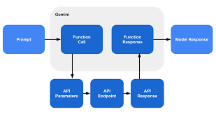

V. Working

* Interactive frontend:

The frontend is built using React Js to give the best user experience. The user interface is easy to navigate and explore.

* Home Page:

The home page features the navigation to the various parts of the website and it also provides details of the website.

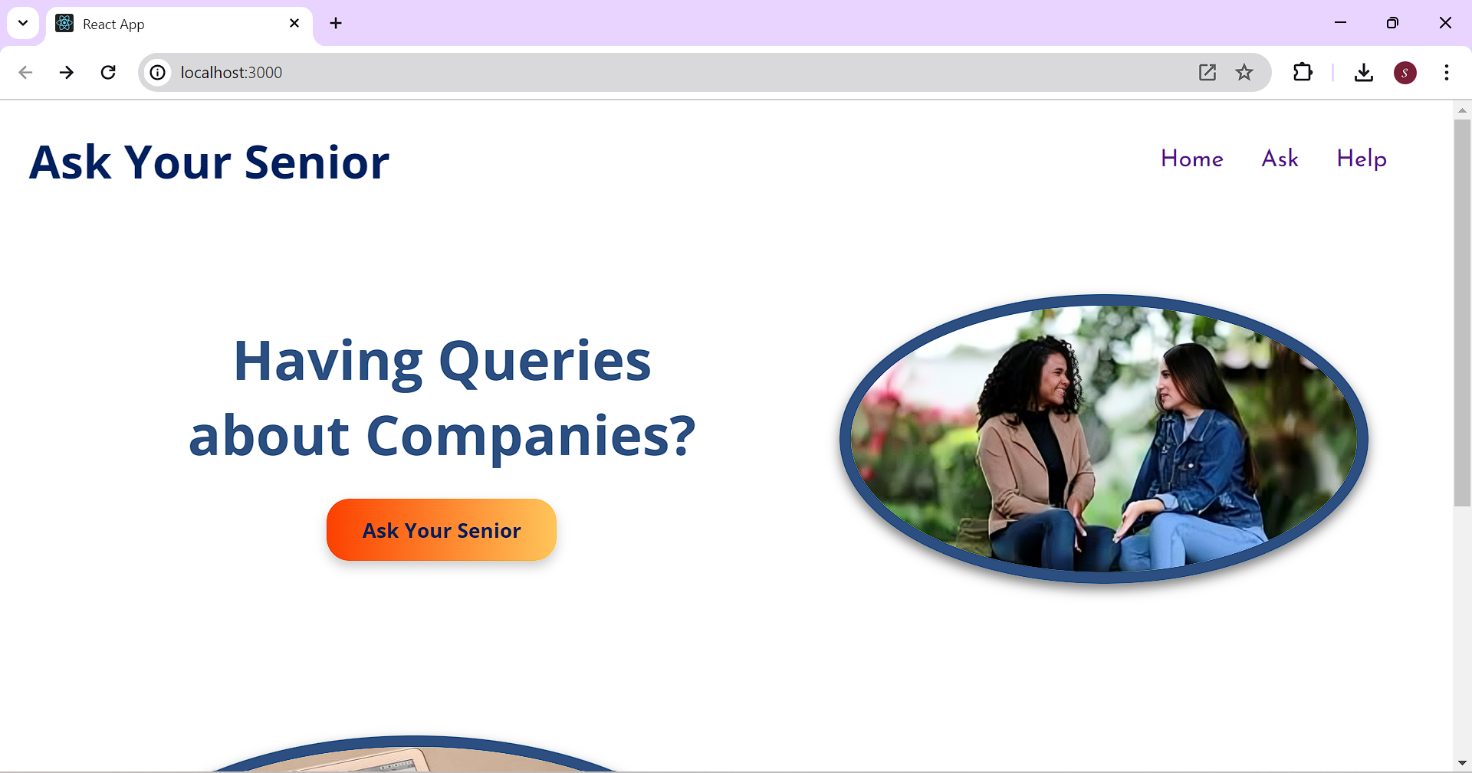

* Data Collection:

The data is collected from the seniors. We have a form on our website which collects the information from the seniors. In the form we collect the details such as name of the company, number of rounds and for each round we collect the information such as topics from which questions asked in each round, questions which are asked in each round and how to prepare for each round. After submitting the form, the content of the form will be stored in a text file.

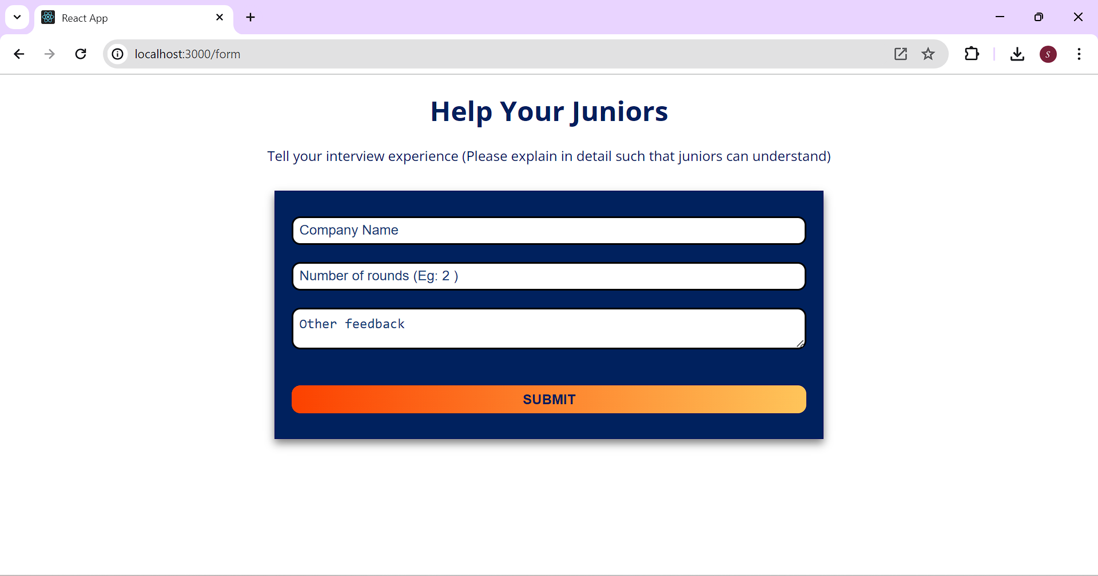

* Storing the data in text file:

The data from the form will be stored in the text file to train the model. The model will train itself from the text file by learning by chunks.For the preprocessing we use the Recursive Character Text Splitter library. The library here is LangChain. This library in turn can be helpful if we plan to split a large document into smaller parts.

* CHATBOT:

This chatbot is built using LangChain and Google Generative AI. The backend is designed using Flask. Using this flask application, we will process the text file and convert it to manageable chunks. We will embed it using Google's Generative AI. We will store the embeddings in the FAISS vector database. We will handle the queries of the user by generating responses using conversational AI model. The environment variables are loaded using the ‘dotenv’ library. This library is used to manage the API key securely.

The function ‘get_text_from_files’ is used to read the text from the file. Next we use the Recursive Character Text Splitter library from LangChain. The text from the file is processed using the ‘get_text_chunks’ from the Recursive Character Text Splitter. This splitter function divides the text into chunks which contain 10,000 characters. It has an overlap of 1000 characters. The overlap is used to preserve the context across the chunks. It is important for generating coherent responses.

VI . Conclusion

This project successfully integrates advanced technologies to create an interactive and user-friendly platform for collecting and processing interview experiences. The frontend, developed with React JS, ensures an intuitive and seamless user experience, making it easy to navigate and explore the website.

The data collection process is streamlined through a form that gathers detailed information from seniors about their interview experiences, including the company name, number of rounds, topics covered, questions asked, and preparation tips. This data is then stored in a text file for further processing.

To handle and utilize this data effectively, the project employs the Recursive Character Text Splitter library from LangChain for preprocessing. This allows the text to be divided into manageable chunks, preserving context and ensuring coherent responses.

The chatbot, built using LangChain and Google Generative AI, is the core feature of the backend. Developed with Flask, this application processes the text file, embeds it using Google's Generative AI, and stores the embeddings in the FAISS vector database. The chatbot efficiently manages user queries by generating responses through a conversational AI model, ensuring a robust and responsive interaction.

Overall, this project demonstrates a comprehensive approach to collecting, processing, and utilizing data for an interactive user experience. The integration of modern technologies like React JS, LangChain, and Google Generative AI, coupled with secure data management practices, provides a reliable and efficient platform for users seeking interview preparation insights.

References

1. S. R. Rahimi, A. T. Mozhdehi and M. Abdolahi, "An overview on extractive text summarization," 2017 IEEE 4th International Conference on Knowledge-Based Engineering and Innovation (KBEI), Tehran, Iran, 2017, pp. 0054-0062, doi: 10.1109/KBEI.2017.8324874.
2. T. Islam, M. Hossain and M. F. Arefin, "Comparative Analysis of Different Text Summarization Techniques Using Enhanced Tokenization," 2021 3rd International Conference on Sustainable Technologies for Industry 4.0 (STI), Dhaka, Bangladesh, 2021, pp. 1-6, doi: 10.1109/STI53101.2021.9732589.
3. C. Lakshmi Devasena and M. Hemalatha, "Automatic Text categorization and summarization using rule reduction," IEEE-International Conference On Advances In Engineering, Science And Management (ICAESM -2012), Nagapattinam, India, 2012, pp. 594-598.
4. C. HARK, T. UÇKAN, E. SEYYARER and A. KARCI, "Graph-Based Suggestion For Text Summarization," 2018 International Conference on Artificial Intelligence and Data Processing (IDAP), Malatya, Turkey, 2018, pp. 1-6, doi: 10.1109/IDAP.2018.8620738.
5. A. Mishra, A. Sahay, M. a. Pandey and S. S. Routaray, "News text Analysis using Text Summarization and Sentiment Analysis based on NLP," 2023 3rd International Conference on Smart Data Intelligen